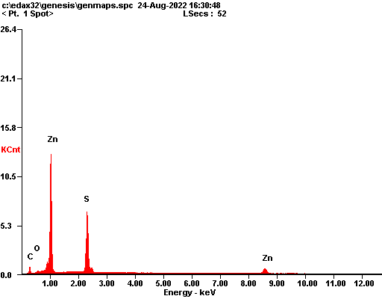

|  |  |  |
| --- | --- | --- |
| ***Element*** | ***Wt%*** | ***At%*** |
| ***CK*** | 14.91 | 40.11 |
| ***OK*** | 01.21 | 02.45 |
| ***SK*** | 31.08 | 31.33 |
| ***ZnK*** | 52.80 | 26.11 |
| ***Matrix*** | Correction | ZAF |

